Kali Li

n

# Date Command

ux Basic Commands

S.Ajith kumar 192011004

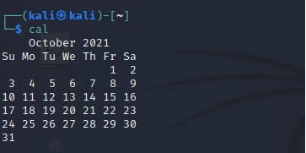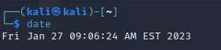

In Kali Linux, the **'date'** command is used to display the **system date** and **time.** In order to display the date, we have to use the following command:

## Syntax:

* 1. # date

# Cal Command

The cal command displays the current **month's formatted calendar** on our terminal

screen. If we require a m re advanced version of **cal,** we can install the **ncal**

o

**package** on our Linux machine, which displays the calendar vertically and provides additional options.

## Syntax

* + 1. # Cal

# Cd Command

The **'cd'** command is also called **chdir** (Change Directory). We used this command

e

to **change** or **switch** the curr nt working directory.

# cp Command

In Kali Linux, the **'cp'** command is used to **copy** files or a group of files that create an exact image of a file on a disk with a different file name.

r directories

o

# whoami Comman

**d**

The **'whoami'** command is

used to print the effective **user**

**ID** whereas

the **who** command prints information regarding users who are presently logged in.

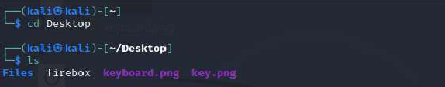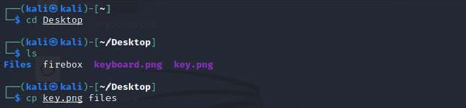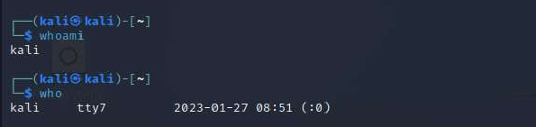

The **"w"** command can also be used to view who is logged on and what they are doing.

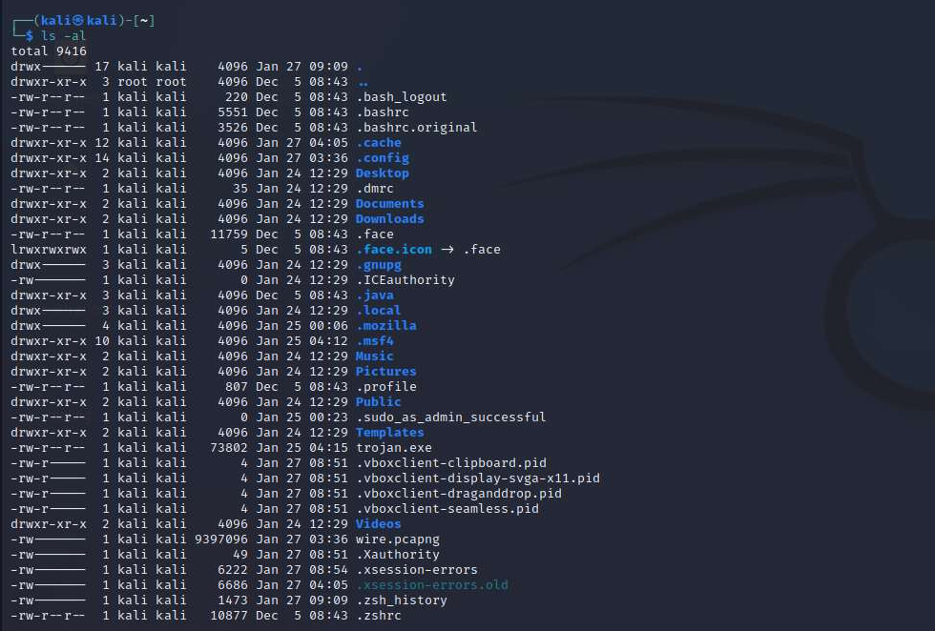

# Ls Command

One of the most useful commands in Kali Linux is the **'ls'** command. The **ls** command lists the directory contents of files and directories. With the help of the **ls** command, we can easily list out every hidden file of a directory with the **-a** attribute, and for more detailed output, we can use the **-l** attribute.

## Syntax

* + 1. # ls -al

# Cat Command

The **'cat'** (concatenate) command is one of Kali Linux's most commonly used commands, permitting us to create single or many files, concatenate files and redirect, view contain of file output in terminal or files.

Usually, we use the cat command to display the content of a file.

* + 1. # cat filename

# mkdir Command

The **'mkdir'** command is us

d to **create directories.** For example, if

e

we wish to

create a directory named **'Penetration testing'** under the **'Documents'** directory, then we have to open a terminal and enter the below command:

1. cd Documents
2. mkdir Penetration testing

# rm Command

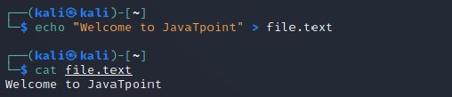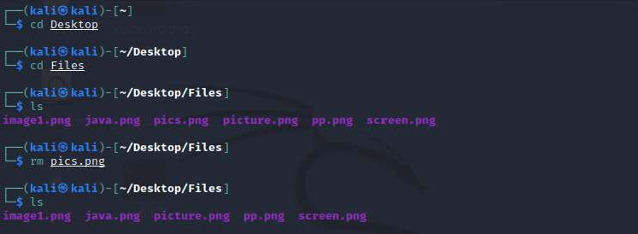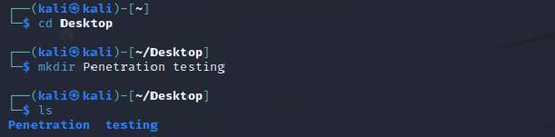

In Kali Linux, the **'rm'** command is used to **delete files.** It can be us directories when we use them recursively.

1. to delete

e

# mv Command

With the help of the **'mv'** command, we can **move** or **renames** files and directories on our file system.

# uname Comman

**d**

The **'uname'** command displays the **current system's information.**

1. can view

W

system information about our Linux environment with the uname command in Linux.

o

With the **uname -a command,** we can learn more about ur system,

**n**

including **Kernel Name, No**

**d**

## e Name, Kernel Release, Kernel Versio

**, Hardware**

## Platform, Processor, and Operating System. Syntax

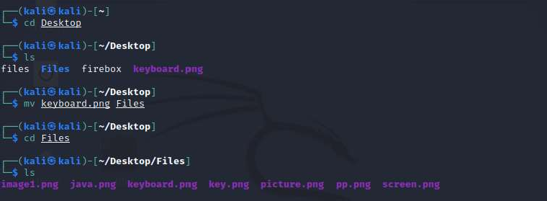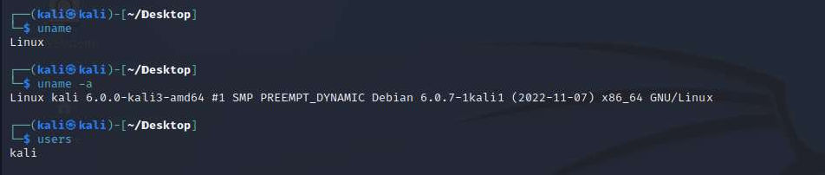

* 1. # uname

# uptime Command

The **'uptime'** command displays the amount of time the system has been running. Uptime's basic usage is simple: simply **type** the name of the command and click **Enter.**

Use the **-p** command-line option if we merely want to know how long the system has been up for and in a more human-readable format.

## Syntax

* 1. # uptime

# users Command

The **'users'** command is used to display the **login names** of users logged in on the system.

## Syntax

* 1. # users

# less Command

In Kali Linux, the **'less'** command is used to view files instead of opening the file. The

less command is a more powerful variant of the **"more"** command whi show information one page at a time to the terminal.

c

h is used to

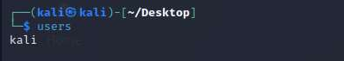

We can view any text file with the help of the **"less"** command simply by typing the following command into a terminal window:

## Syntax:

* 1. # less /etc/passwd

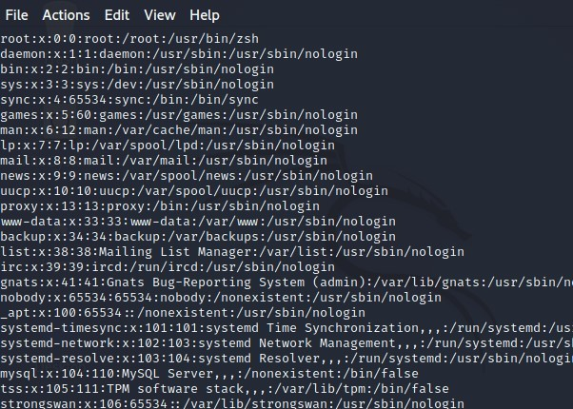

# more Command

The **"more"** command permits us to show output in the terminal one page at a time. This is particularly beneficial when using a command that requires a lot of scrolling, such as the '**ls'** command or the **'du'** commands.

The **'more'** command works with any applications that output to the screen. A good way to test this is to type the following command into a terminal window:

## Syntax:

* 1. # moreetc/passwd

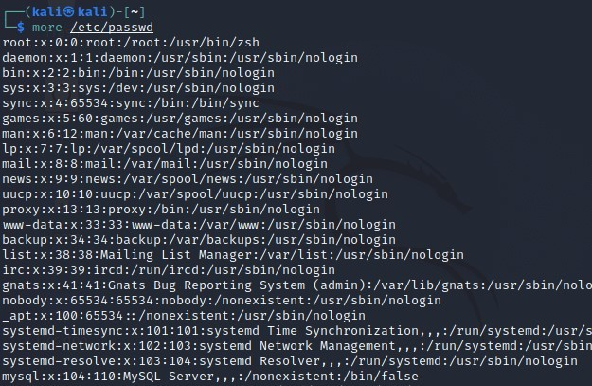

# vi Command

The **'vi'** editor is a screen editor that comes with practically every **UNIX** system. The **command mode** and the **insert mode** are the two most common nodes in vi.

In order to start entering text in an empty file, we have to first switch from the command mode to the insert mode. To accomplish this, start typing the letter i. When we start typing, anything then the type will be entered into the file.

Type some short lines, then press Return at the end of each. **Vi** does not use word wrap like other word processors. It will break a line at the screen' edge. If we make a mistake, we can undo it by pressing the **Backspace** key. If the Backspace key on our computer is not working, then try the **ctrl + h** key combination.

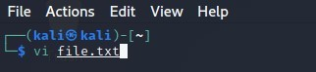

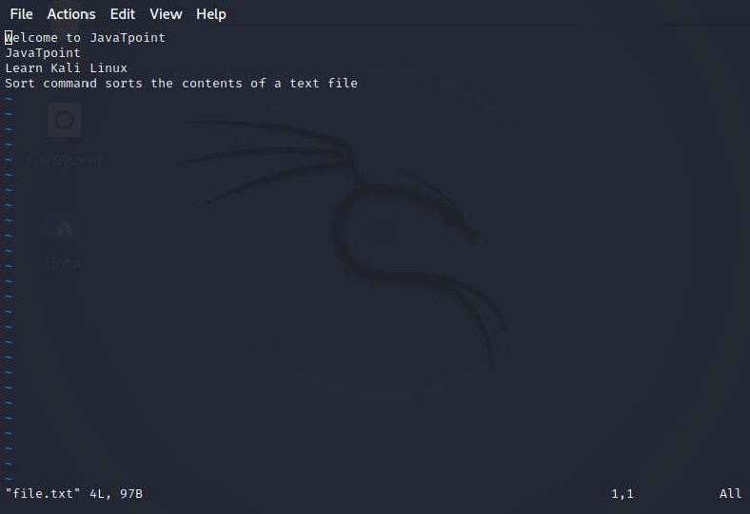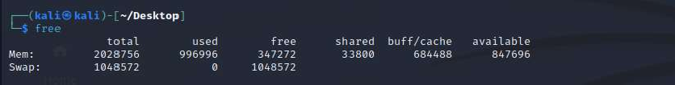

# free Command

In Kali Linux, the **'free'** command provides us the useful information about the **amount of RAM** available on a Linux machine. It also displays the entire amount of **physical memory** used and available space, as well as **swap memory** with **kernel buffers.**

## Syntax:

* 1. # free

If we use the **free** command with the **-t** option, it would list the total line at the end.

1. sort Command

Using the **'sort'** command, we can sort the content of the text file, line by line. Sort is a standard command-line program which prints the lines of its input or concentration of all files listed in its argument list in sorted order.

## Syntax:

* 1. # sort file name

We can reverse the order of any file's contents by using the **-r** sort.

## Syntax

1. # sort -r

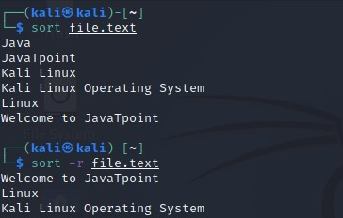

# history Command

The **'history'** command is one of Kali Linux's most commonly used commands. The history command in the bash shell saves a history of commands entered that can be used to repeat commands.

We can run the history command by itself, and it will just print the **current user's bash history** on the screen, as shown below:

## Syntax:

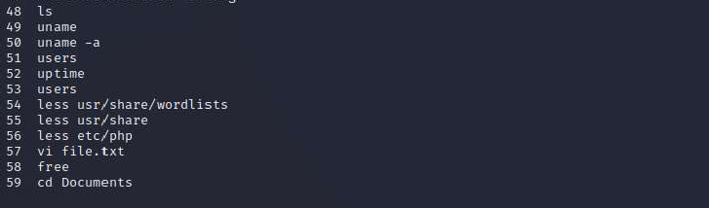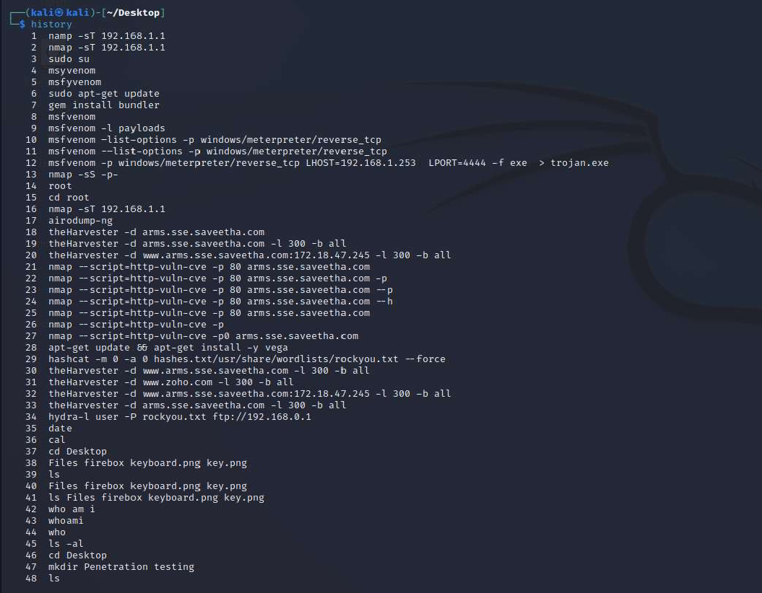

* 1. # history

# Pwd Command

In Kali Linux, the **'Pwd'** command is used to **print working directory.** It gives us information about the directory we are now in. This is especially useful if we need to access the directory while in the middle of a complicated process.

